

“Python Programming”

Assignment-2

Topic – Analysing and Reporting Student Grades

Submitted by – Tiya Mishra
Roll no - 2501730026
Course – B. Tech CSE (AI & ML)
Section – B
Faculty name- Mr Sameer Farooq

Introduction
The objective of this Python Lab assignment is to develop a GradeBook Analyser, a program capable of reading student marks, performing statistical analysis, assigning grades, and presenting results clearly. The project demonstrates Python skills such as:
- File handling
- Functions and modular programming
- Data validation
- Statistics (mean, median)
- Grade assignment logic
- Table formatting for output

Objectives
-To develop a Python program that can efficiently analyse student marks.
-To implement file handling using CSV files
-To practice modular programming using functions
-To design a grading system based on score ranges
-To generate summaries for academic performance evaluation

Program Description
The program developed (gradebook_analyzer.py) is designed to analyse student marks and generate performance summaries. It allows users to either enter marks manually or load them from a CSV file.

Program Code

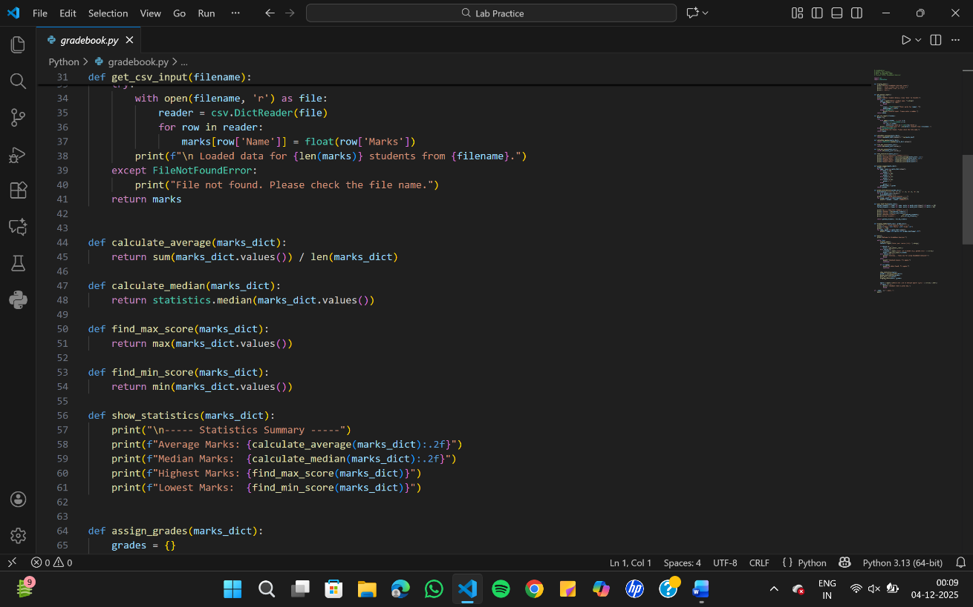

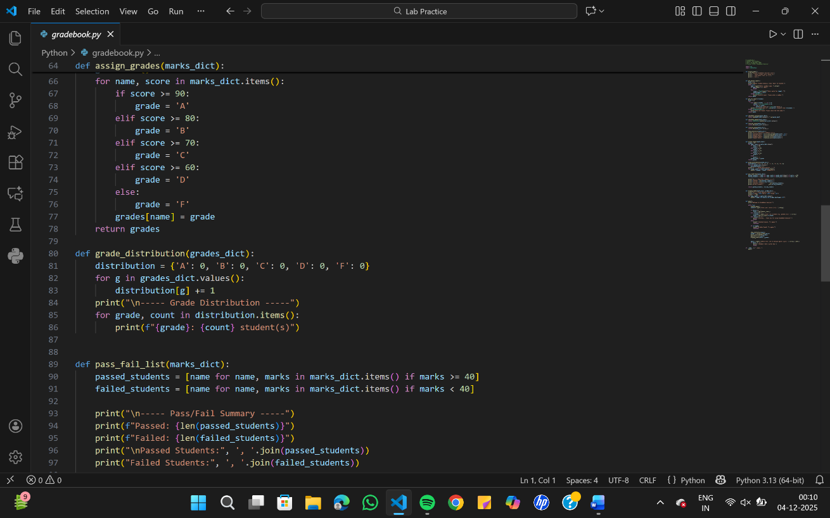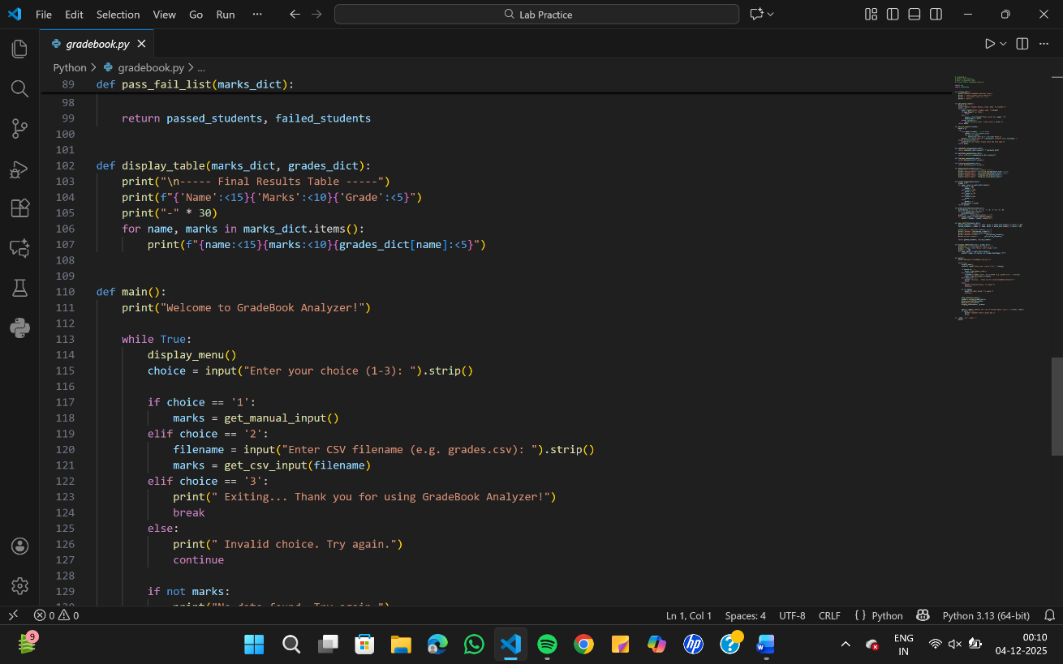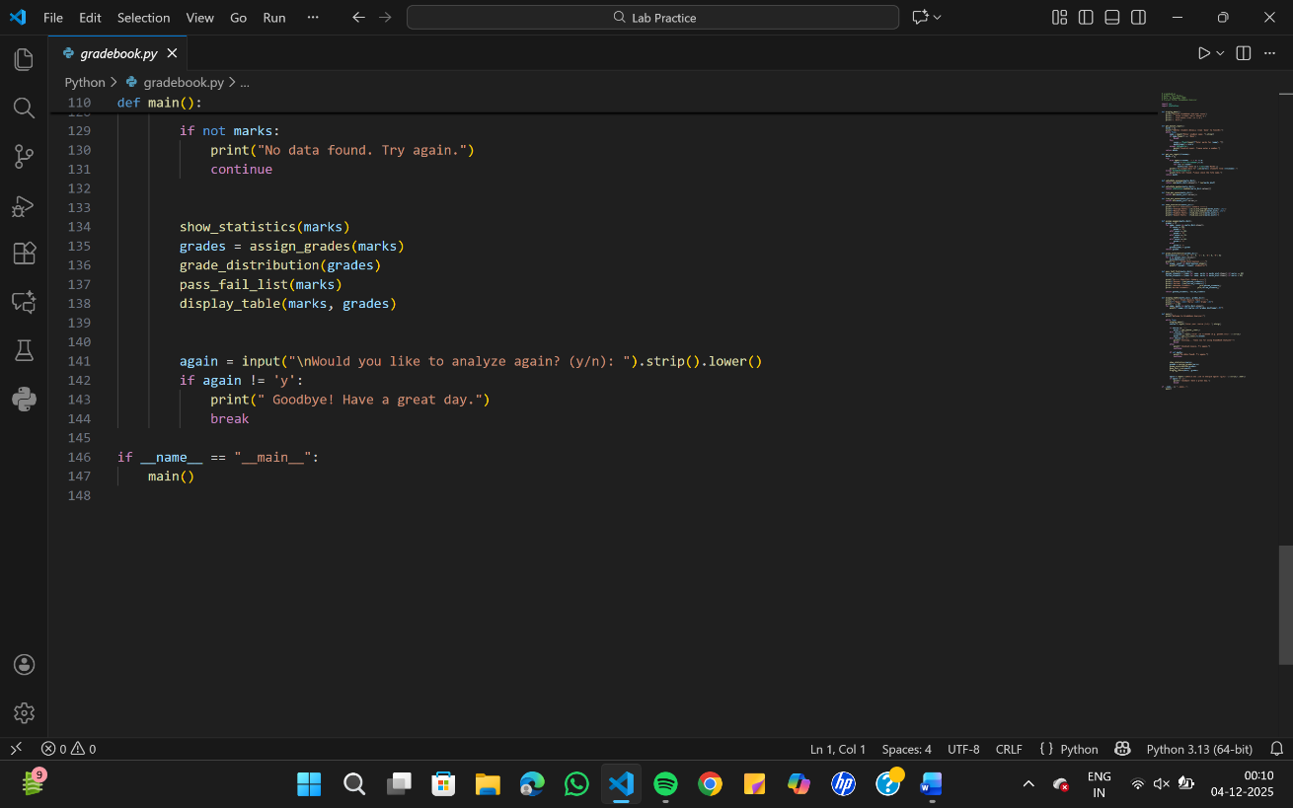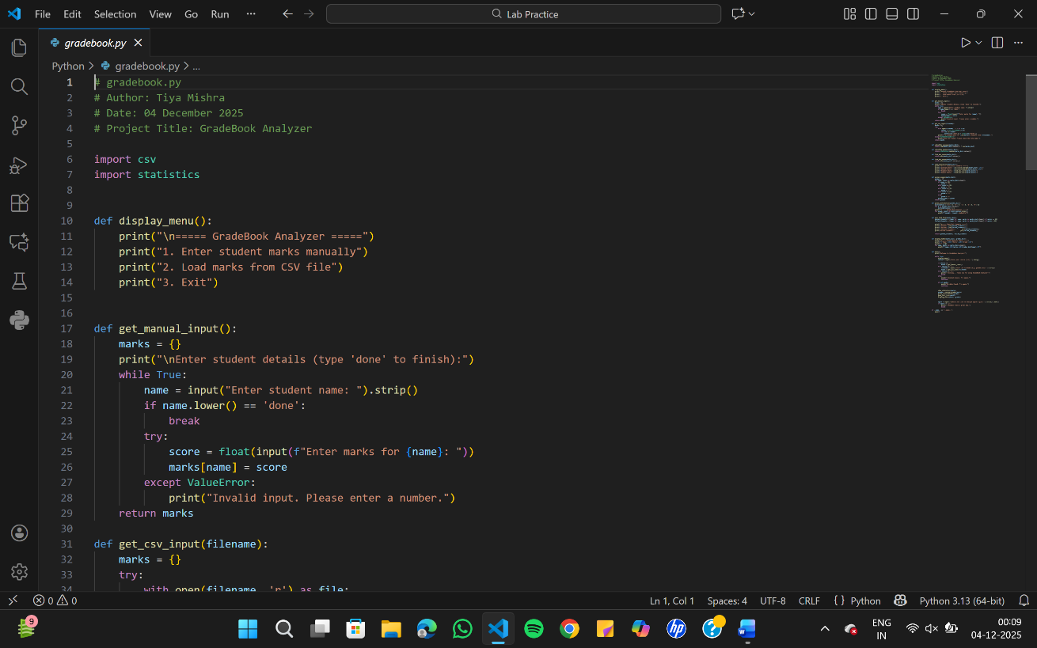

Sample Output
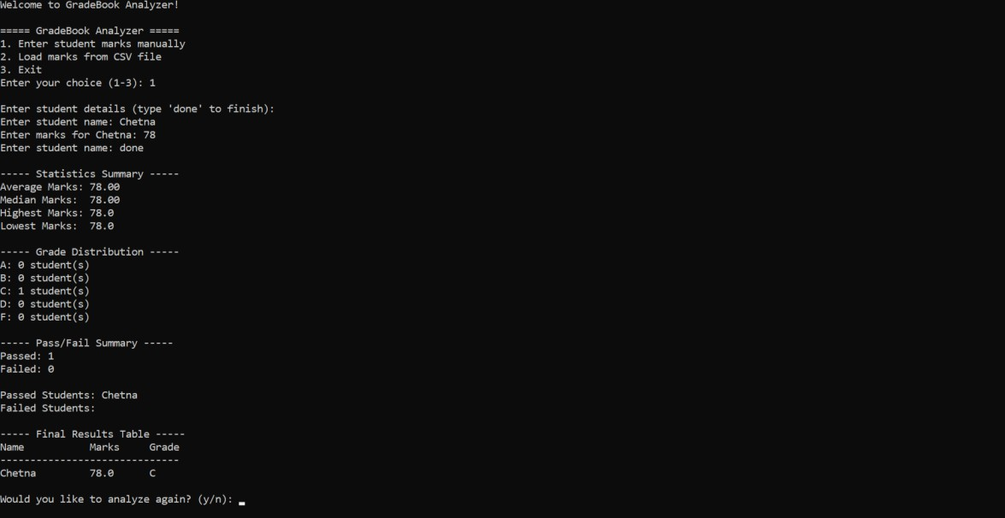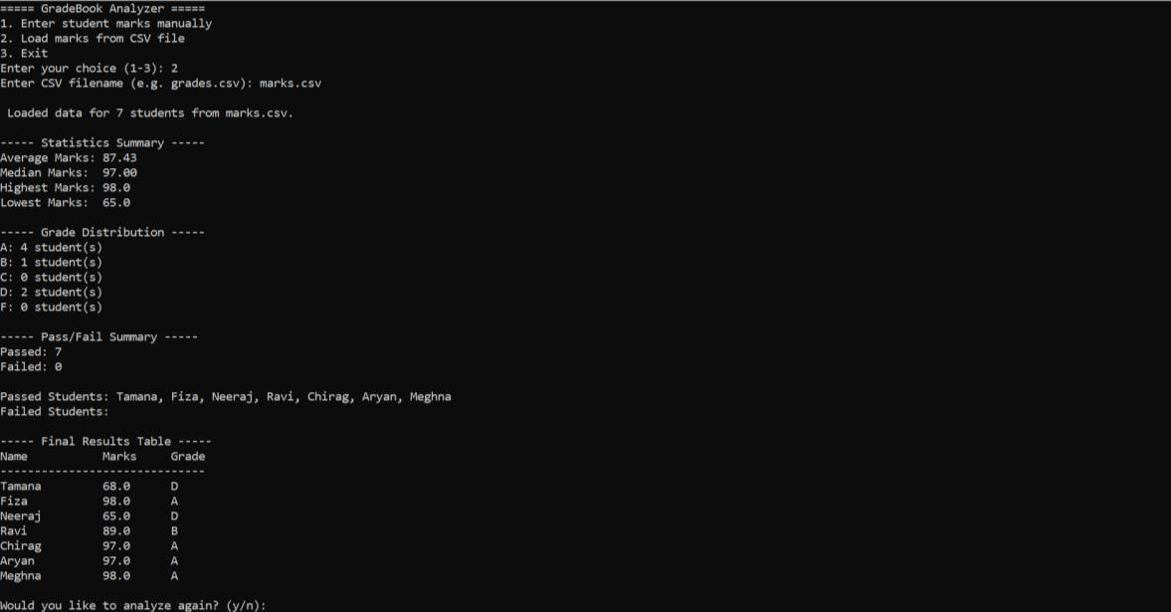

Conclusion
The GradeBook Analyser is an effective Python program that reads student marks, performs statistical analysis, assigns grades, and displays results clearly. It demonstrates essential programming skills such as file handling, functions, and data processing, providing a practical solution for evaluating student performance.

